Pairing Students Using the Split Half

This pairing strategy helps so that the highest and lowest performers are not partnered, yet the partnership supports the lower performing students.

Step 1: Rank your students from the highest performer to the lowest performer.
Step 2: Split them in half (e.g., if there are 14 students, there should be a group of 1–7 and 8–14).
Step 3: Pair up the highest performers from each group.
Step 4: If necessary, reassign pairs taking into consideration behavioral issues and peer relationships.

Student 1 | Student 11 | Pair #1
Student 2 | Student 12 | Pair #2
Student 3 | Student 13 | Pair #3
Student 4 | Student 14 | Pair #4
Student 5 | Student 15 | Pair #5
Student 6 | Student 16 | Pair #6
Student 7 | Student 17 | Pair #7
Student 8 | Student 18 | Pair #8
Student 9 | Student 19 | Pair #9
Student 10 | Student 20 | Pair #10

Rules for Working in Pairs

- Talk only to your partner and only about math.
- Use a 6-inch voice.
- Cooperate with your partner.
- Try your best

Numbered Heads Together

Materials:
- Two sets of numbered squares, popsicle sticks, etc.
- A group container
- A person container
OR
- Download: Pretty Random - Random Number Generator.

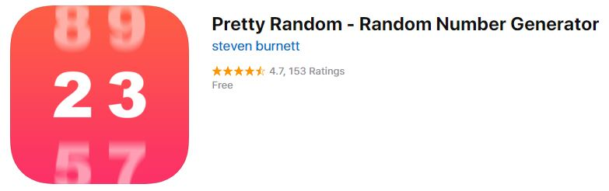

Procedure:
- Place students in pairs or triads.
- Assign each group a number.
- Assign each student a number.
- Students work together to solve the problem and practice how they will explain their solution procedure to the class.
- When it is time to debrief:
  - Choose a number from the group container to identify the group.
  - Choose a number from the person container to identify the person who will explain the solution procedure.
OR
- Use the Random Number Generator to identify the group and the student.

